Lab 3 – Advanced Dart Practice Exercises
1. Objective
This lab helps students strengthen their understanding of advanced Dart features—including asynchronous programming, streams, microtasks, JSON handling, and factory constructors—by completing five hands-on exercises that can run directly on DartPad or in Android Studio / VS Code.
2. Requirements
Complete five mini-projects demonstrating advanced Dart concepts:
1. Product Model & Repository – build a data model and a repository with both Future and Stream behaviors.
2. User Repository with JSON – simulate fetching and parsing JSON data from an API.
3. Async + Microtask Debugging – illustrate event-loop and microtask order.
4. Stream Transformation – apply functional operations such as map() and where() to a stream.
5. Factory Constructors & Cache – demonstrate singleton and factory patterns.
All tasks must:
· Execute without error in DartPad or Flutter’s integrated Dart runtime.
· Include brief inline comments explaining logic and expected output.
· Print key results to the console.
3. Guided Steps
Exercise 1 – Product Model & Repository
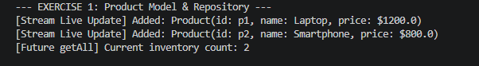
Exercise 2 – User Repository with JSON
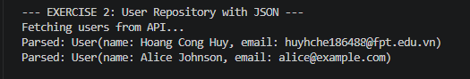
Exercise 3 – Async + Microtask Debugging
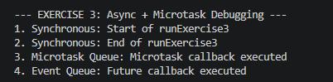
Exercise 4 – Stream Transformation
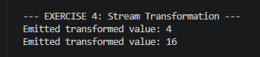
Exercise 5 – Factory Constructors & Cache
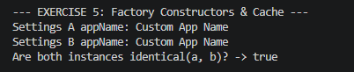
4. Expected Results
· Each exercise compiles and prints its output in order.
· Console shows proper stream events, microtask execution sequence, and singleton confirmation.
· Students understand how to handle asynchronous flows and object creation patterns in Dart.
5. Submission
· Deliverable: Single Dart file or zipped project containing five completed exercises.
· Evaluation Criteria:
o Correct implementation and syntax (40%)
o Code clarity and comments (20%)
o Output accuracy (20%)
o Use of async / stream features (20%)

